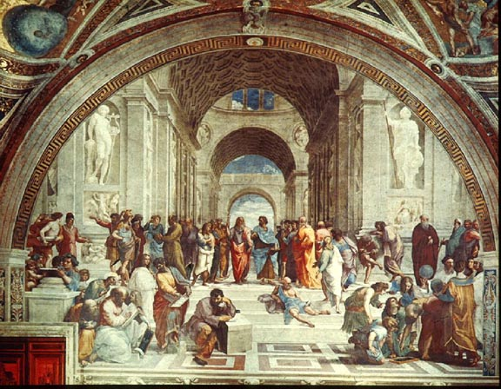Intro to Europe, Renaissance

AP Euro Homework Assignments

DATE: 11/06/15

TOPIC: “Intro to AP European History”

1. Introduction
2. Syllabus and interest sheets
3. Distribution of Books
4. Student completion of European maps –Quiz on Wednesday

HOMEWORK:

1. P/C pp. 1-8

(Geography and History)

1. Cover books (McKAY)
2. Study for Map Quizzes
3. P/C pp. 9-46: Section 1-4 {**general survey of text/Study Guide** due Tuesday and Wednesday}

(Ancient Times, Early/Middle/High Middle Ages)

______________________________________________________________________________

DATE: 11/10/15

TOPIC: “Grand Survey on the Middle Ages”

1. Lecture on Middle Ages

HOMEWORK:

1. P/C pp. 9-46: Section 1-4 {**general survey of text/Study Guide** }

(Ancient Times, Early/Middle/High Middle Ages)

1. Study for Political European Map Quiz

______________________________________________________________________________

DATE: 11/11/15 *Veteran’s Day*

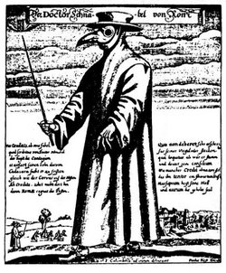

TOPIC : “Grand Survey on the Middle Ages”

1. **Political European Map Quiz**
2. Finish Lecture on Middle Ages

HOMEWORK:

1. 100 Years War Study Guide
2. Study for Physical Map Quiz

_______________________________________________

DATE: 11/12/15

TOPIC: "Calamitous 14th Century"

1. **Physical Map Quiz**
2. Discuss Questions and Terms
3. Lecture on Black Death

HOMEWORK:

1. Study for Middle Ages Quiz – Friday, November 13
2. Black Death Reading

--------------------------------------------------------------------------------------------

DATE: 11/13/15

TOPIC: "Calamitous 14th Century"

1. **Greece, Rome, and Middle Ages Quiz**
2. Black Death Discussion & Video

HOMEWORK:

1. Background of Renaissance Study Guide

DATE: 11/16/15

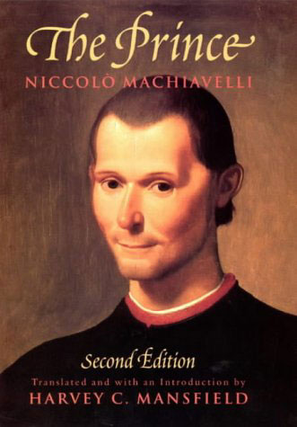

TOPIC: "Hallmarks of Intellectualism"

1. Lecture on the Background of Renaissance
2. Renaissance Activity

HOMEWORK:

1. Renaissance Study Guide

_______________________________________________________________________

DATE: 11/17/15

TOPIC: "Renaissance Art and Culture "

1. Lecture on Art and Culture
2. Michelangelo Film

HOMEWORK:

1. Machiavelli Reading and Preparation

_________________________________________________________________________________________

DATE: 11/18/15

TOPIC: "The Prince"

1. Machiavelli Debate and Notes

HOMEWORK:

1. Exploration Chart

DATE: 11/19/15

TOPIC: "Study of Exploration"

1. Exploration Chart Discussion
2. Explorer activity

HOMEWORK:

1. Study

___________________________________________________________________________________________________________

DATE: 11/20/15

TOPIC: Review HOMEWORK:

1. Review Activity 1. Study for Exam tomorrow

____________________________________________________________________________________________________________

DATE: 11/23/15

TOPIC: Renaissance Test

1. Complete Unit 1 Exam

HOMEWORK:

1. 1st Reformation Study Guide

DATE: 11/14/14

TOPIC: "Northern Renaissance"

1. Lecture on Renaissance outside of Italy
2. Art Gallery

HOMEWORK:

1. P/C pp. 77-90: Section 09 (The Protestant Reformation)
2. Study for Renaissance Quiz – Monday, November 17

________________________________________________________________________________________

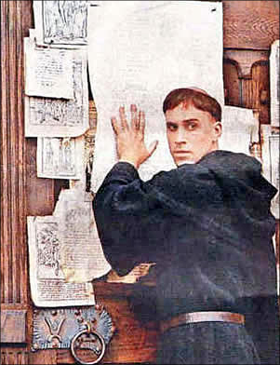DATE: 11/17/14

TOPIC: "Luther's Protest"

1. **Renaissance Quiz**
2. Video on Printing Press
3. Lecture on Protestant Reformation (The Overthrow of Napoleon)
4. Venn Diagram

HOMEWORK:

1. P/C pp. 90-96: Section 10 – Tuesday, November 18

(Catholicism Reformed and Reorganized)

DATE: 11/18/14

TOPIC: “Spread of Protestantism I"

1. Group research of assigned religion in library.
2. Group preparation of presentation.

HOMEWORK:

1. Work on Religion Presentations – due Thursday, November 20th

DATE: 11/19/14

TOPIC: "Luther’s Protest"

1. Finish Luther Notes
2. Sec 9 ?s and Terms
3. Venn Diagram
4. Writing Preparation

HOMEWORK:

1. Religion Presentations tomorrow

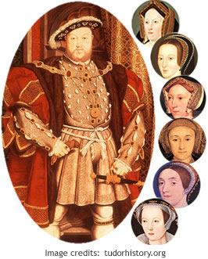DATE: 11/20/14

TOPIC: "Spread of Protestantism II"

1. Group presentations on religion.
2. Lecture on spread of Protestantism and Catholic response.
3. Counter Revolution Lecture
4. Writing Preparation

HOMEWORK:

1. Study for Exam - Tuesday, December 2

_________________________________________________________________________________________________

DATE: 11/21/14

TOPIC: Review 1st Unit

1. English Reformation
2. Peer Edit - Essay Discussion
3. Anne Boleyn Documentary

HOMEWORK:

1. Study for Exam – Tuesday, December 3

DATE: 12/01/14

TOPIC: Review HOMEWORK:

1. Review Activity 1. Study for Exam tomorrow

____________________________________________________________________________________________________________

DATE: 12/02/14

TOPIC: Chapter 1 & 2 Exam

1. Complete Unit 1 Exam

HOMEWORK:

1. P/C pp. 97-104: Section 11 – due Wednesday, December 3 (The Opening of the Atlantic)